Name:S.Venikalaxmi
Reg.No:24MIS0117
Cloning- lab 3
1.created repo and contacts.py is pushed
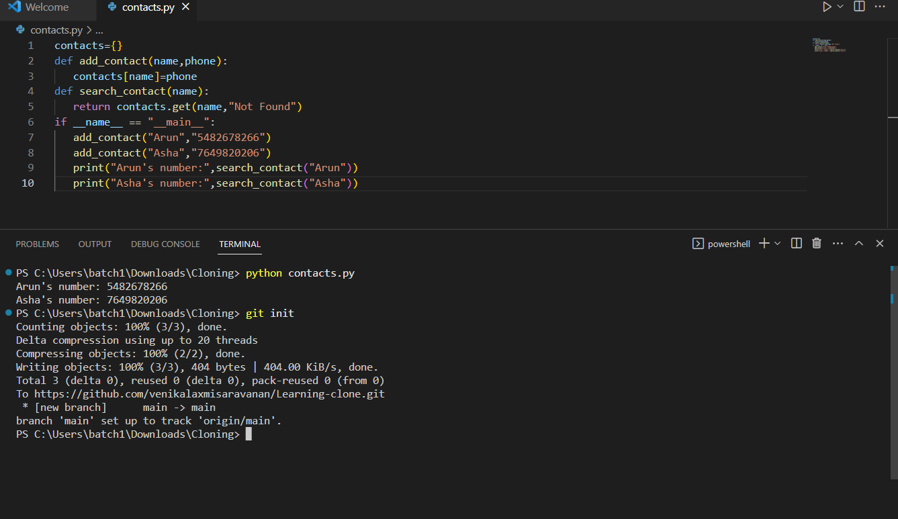
2.cloned the program
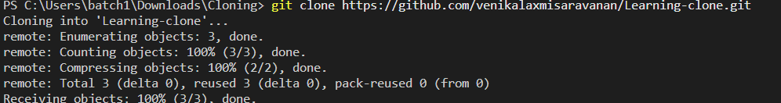

3.folder created after clonning
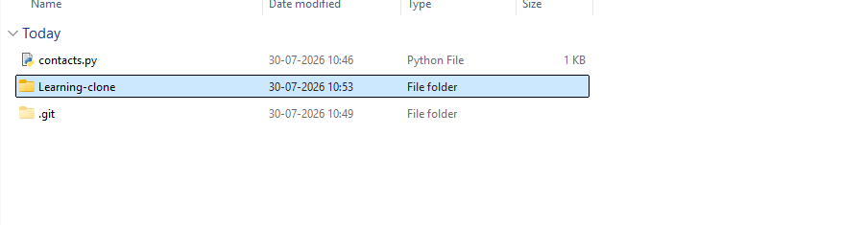

4.created new branch and modified the code of clonned file and merged the file in main branch
